ILS EQUIPMENT SPECIFICATION
INFLATABLE RESCUE BOAT (IRB)

This equipment specification is a guide to pooled equipment for use in ILS competition. It is to ensure uniformity of equipment and consideration of safety aspects. It may also to assist countries who wish to develop new craft.

Note: ILS countries may have specific lifesaving needs and IRB equipment requirements should be separately considered to ensure that lifesaving equipment meets the country’s assessed needs.

1. GENERAL SPECIFICATIONS

The following drawings give a general guide to the design and shape of IRB Hulls. The measurements shown on the drawings are in millimetres.

IRB/C1-1c General Soft Hull IRB Side Elevation and Section
IRB/C1-2c General Soft Hull IRB plan
IRB 3_50_SR_DLRG Rigid Hull General Specifications
IRB/C1-3c Stern Details
IRB/C1-5c Re-righting Rope and Pouch
IRB/C1-6c Crew Hand Grips and Foot Straps
IRB/C1-9c Motor Safety Cables
IRB/C1-11a Optional “V” Planing Strake
IRB/C1-14 Paddle and Holders
IRB/C1-15a Rescue Tube Holder
IRB/C1-17a General Arrangement Foot Strap Locations

2. HULL

- The length shall be a minimum of 3.50 metres and a maximum of 3.9 metres.
- The width shall be a minimum of 1.6 metres and a maximum of 1.8 metres.
- The hull shall incorporate a pontoon having at least three (3) separate inflatable buoyancy tube compartments in sequence around the perimeter, sponson to sponson.
- The hull shall incorporate a separate inflatable compartment (keelson) in addition to the three buoyancy tube compartments, or shall have a moderate v shaped rigid fiberglass, aluminum or other approved hull similar to the drawings in the diagrams.
- The inflatable pontoon shall be a minimum diameter of 430m and a maximum diameter of 475mm and shall be shaped to a conventional bow (i.e. one that comes to a point and not that of a barge or wedge shape) and extend a minimum of 300mm aft of the transom before tapering to a cone.
- The internal dimensions of the IRB boat shall be a minimum of 1.8 metres in length from the spray dodger (if fitted) to the transom and a minimum width of 0.725 metres between any point of the starboard and port pontoons. These dimensions are intended to and must allow for sufficient internal floor area to enable patient resuscitation to be performed on an outstretched (175cm tall) adult.
- The boat shall be fabricated from a durable, impervious material and shall be sun, oil and petrol resistant e.g. polyester/nylon based material, 75 percent hypalon (outer layer)/neoprene or similar (inner layer). Note. PVC based materials are not acceptable. The pontoon colour shall be air sea rescue red/orange. The hull colour shall be the same as the pontoons, or as an alternative rescue yellow. The minimum grade material used throughout the boat shall be 840 denier for nylon and 1100 decitex polyester base cloth.
- The pontoons shall be fitted with three hand grips, one for the driver and one for a patient on the port pontoon and one for the crewperson on the starboard pontoon (or bow inboard) and shall be of a soft type.
- Any grab handles or towing eyes placed at the bow of the boat should be flat and/or recessed to reduce the chance of injury.

Note: All the above measurements may have a tolerance of ± 5%.

3. FLOOR DECKING

The floor deck shall incorporate features that provide a non slip surface, fastenings to locate and hold the fuel tank in the bow section and foot straps for the driver and crew person.

Note: An example of the fuel tank fixings are shown below. PVC tubing covering rope loops must have a minimum external diameter of 10mm.

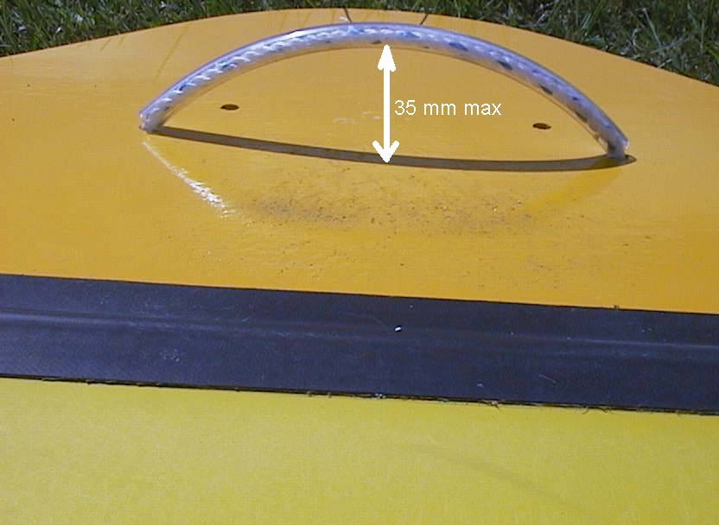 | 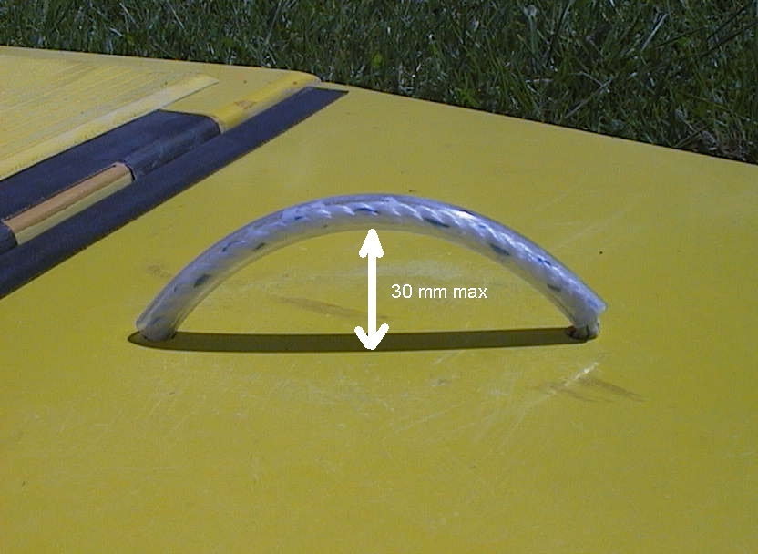
Floor Board Top Loop  (35mm high) | Floor Board Side Loop  (30mm high)
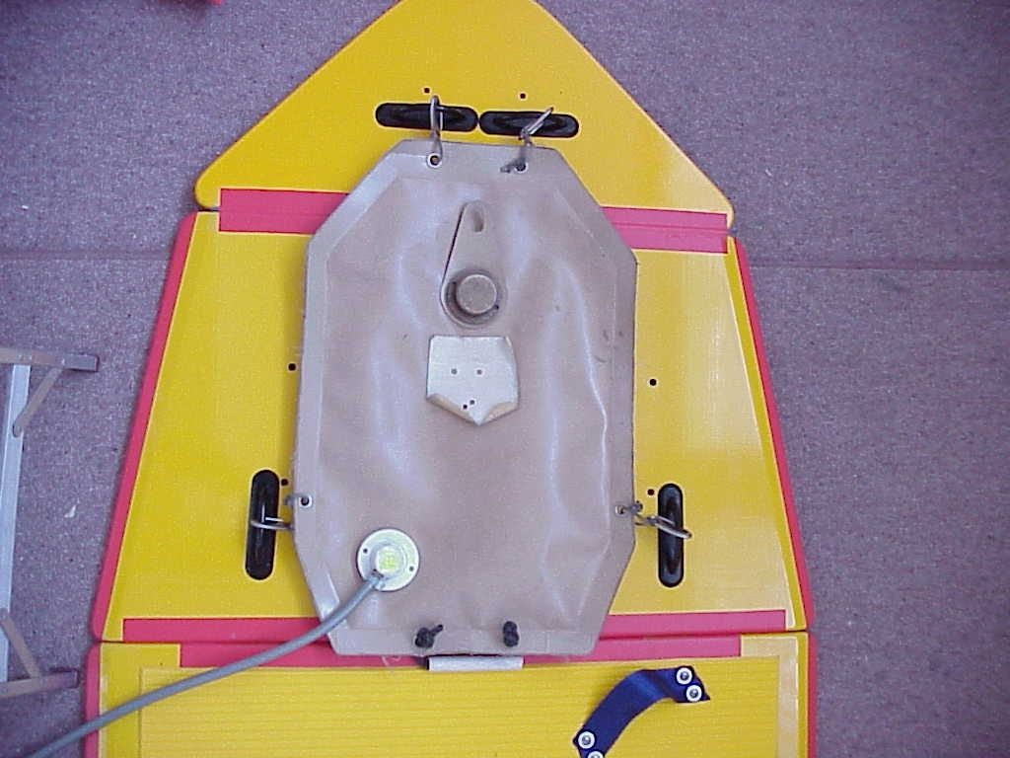

Floor Board with Fuel Cell Attached

4. TRANSOM

(i). The transom shall be a minimum thickness of 36mm and be of minimum strength equivalent to 36mm thick marine ply, shaped to the pontoons and providing a centre height of 390mm to cater for a standard 25/30hp short shaft outboard motor.
(ii) An eye bolt shall be fitted to the transom to hold a Motor Safety Cable.
- A “Motor Safety Cable” shall be supplied. The cable must be flexible stainless steel of 4mm in diameter, PVC or rubber sleeved, complete with a 70mm stainless steel snag free snap hook at one end and a “D” shackle at the other end. The safety cable shall be 1000mm overall length with a 25mm eye on each end. The cable shall completely wrap around the motor shaft so that it can be clipped back onto itself and shackled to the eye bolt. The PVC or rubber sleeve shall encapsulate the crimped cable joint as well as the cable.
- The transom must be fitted with a “Motor Bracket Wearing Plate”. The inner face shall have a 5mm minimum lip to prevent the motor clamps from accidentally slipping off the transom. The wearing plate shall be of one piece configuration (5mm thickness). All fixings shall be stainless steel.

5. THE BOAT

- The boat shall be designed to suit a 25-30 HP rated outboard motor and be capable of planing whilst carrying a minimum of four persons each with an average weight of 75kg.
- The maximum weight of the boat excluding outboard motor and fuel tank shall be 80kg for an inflatable hull or 100 kg for a rigid hull.
- The bow of the boat shall incorporate a crewperson’s bow rope, complete with standard handle.
- A re-righting rope shall be provided fixed to the starboard pontoon and made to a length capable of re-righting the boat with one or two people. The rope shall be housed in a pouch complete with “D” ring and be glued to the side of the boat.

The IRB shall be measured with the IRB fully inflated to the recommended air pressure.

6. ENGINES

Engines may be either two-stroke or four-stroke design and shall be a maximum of 25-30 horsepower to be used in competition. It is preferable that engines have short shaft.
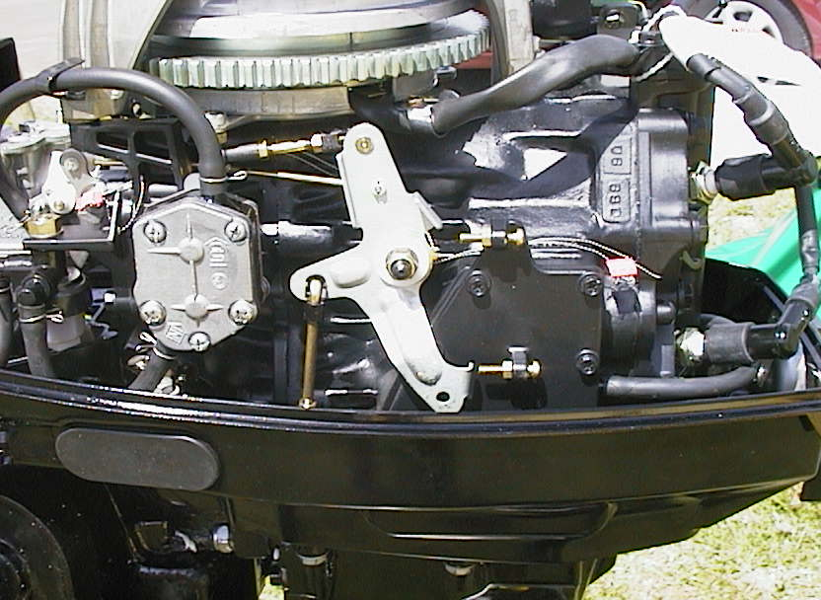

All Engines must have ILS or Country of origin “seals” intact and the powerhead must be in original condition i.e. a powerhead that has been modified is no longer eligible for use in ILS Competition. The following items are allowed.

- Air box may be drilled or relieved on the back but not on the front or sides

- Thermostat may be drilled or removed

- Accessory Lighting Coil may be removed

- Spark Plug Connector Cap/HT leads may be replaced under normal maintenance with suitable substitutes

- Water Pump Tell Tale Outlet may be relocated to the opposite side

- Engine Mounts may be replaced with solid substitutes

- Ignition Timing will not exceed manufacturers specification

- Approved Stop Switches may be fitted

- Stop Switch/Button may be relocated to Fuel Bayonet Connection position

- Fuel Bayonet Connection may be relocated to the Stop Switch/Button position

- Pull Start Handle will be as supplied with the engine with a maximum 130mm extension beyond the cowling cover exit.

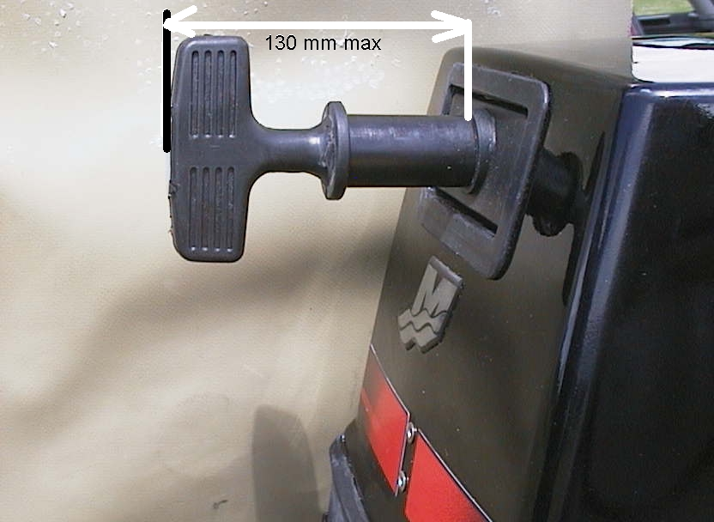
:

6.1 Clamp Screws

These will be as supplied with the engine. The use of “spinner” type handles is permitted providing the design and function of the handle is adequate to allow sufficient leverage to secure the engine to the transom.

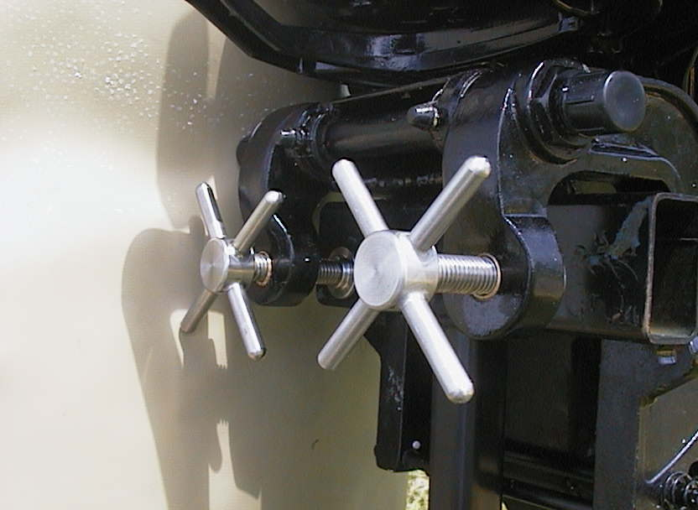

6.2 Spark Plugs

- Only the listed (manufacturer recommended) Spark Plugs may be used.

7 PROPELLERS

- There is no restriction on propellers provided they comply with all clearances and requirements of Country approved propeller guards and the engine is fully operable under normal loading.
- The leading and trailing propeller blade edges must be contained inside the ring guard.

8 PROPELLER GUARDS
- Propeller guards must be Country approved and must not be modified in any way from the manufacturer/supplier specification (excluding the screws/bolts/support plates attaching the propeller guard to the engine cavitation plate).
- The propeller guard must be manufactured from stainless steel or another material approved by the ILS member association and have a minimum thickness of 3mm
- The vanes must be of 3mm x 12mm minimum.
- The vane spacing will be a maximum of 24mm with a sufficient number of vanes (approx 11) to accommodate minimal vertical apertures between bottom vanes, skeg and ring.
- The ring will be 3mm minimum thickness and the leading and trailing propeller blade edges will be contained within the ring.

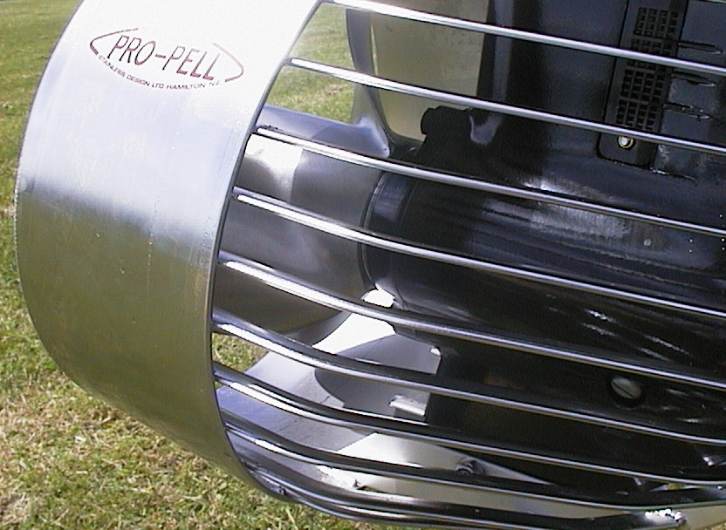
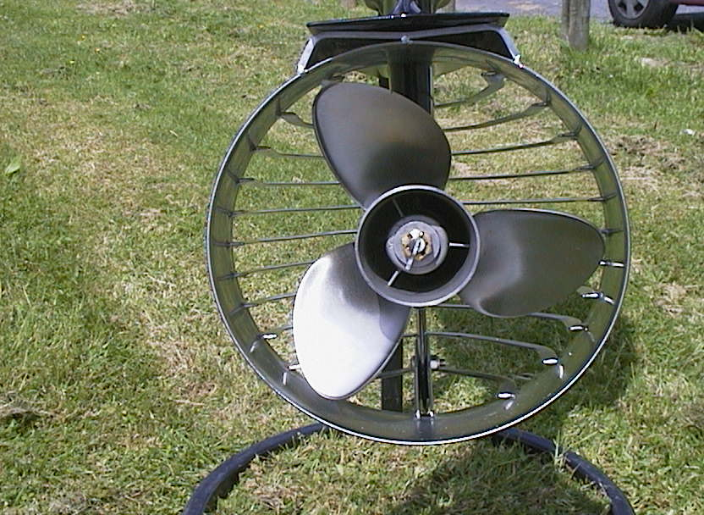
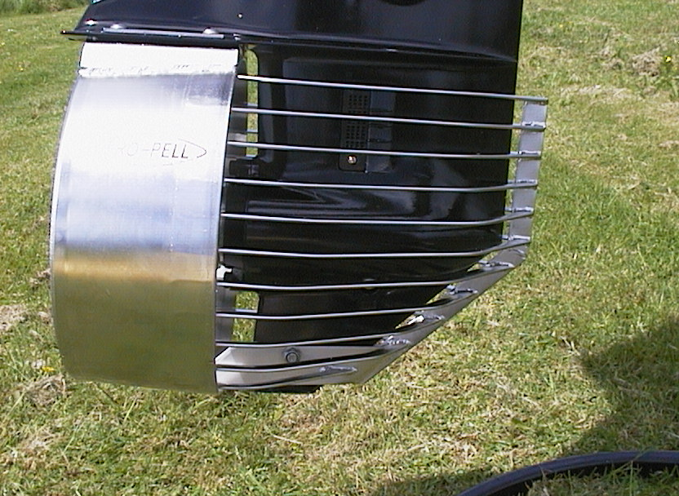

9 ENGINE SAFETY STROP

- The engine safety strop must be Country approved and must not be modified in any way (including the use of heat shrink/tape/Velcro etc.).
- The safety strop must be fitted with a type 2470 (70mm x 31mm) stainless steel spring snap hook .

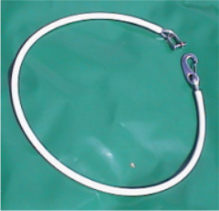

10 FUEL

- Dependent on the type of engine the Host Country will provide two-stroke fuel (petrol/outboard 2 stroke oil) or four-stroke (petrol only) for compulsory use in all engines competing in ILS Competition. This will be standard automotive fuel as recommended for use by the motor manufacturer.

11 FUEL BLADDERS/CELLS

- The fuel bladder shall be of the soft type that collapses as the fuel is consumed. If such fuel bladders are not permitted by law the host will provide other tanks according to the national legislation. Fuel cells shall be safely affixed to the IRB.

11.1 Fuel Bladder Clip
- The type 2470 (70mm x 31mm) stainless steel spring snap hook is the approved clip for use at ILS Competition.

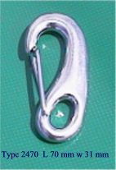

1.2 Fuel Bladder Clip Attachment
- The intention of fuel bladder clip fixture is to ensure no rigid type fixing that could expose the IRB crew to potential injury.

- The fuel bladder must be fitted with four (4) type 2470 (70mm x 31mm) stainless steel spring snap hooks independently attached with rope to the eyelets or through the carry handles.

- The rope type and diameter is not restricted but the rope length between the clip and bladder attachment point will be determined by allowing minimum travel of the fuel bladder from its designated position.

- The rope must be of sufficient strength to retain the fuel bladder during all maneuvers.

- The rope may be supported by the use of tape/heat shrink but this must not encroach onto the clip.

- Clips must be attached to the fuel bladder in such a way as to allow a 180-degree rotation between the clip and the fuel bladder attachment point.

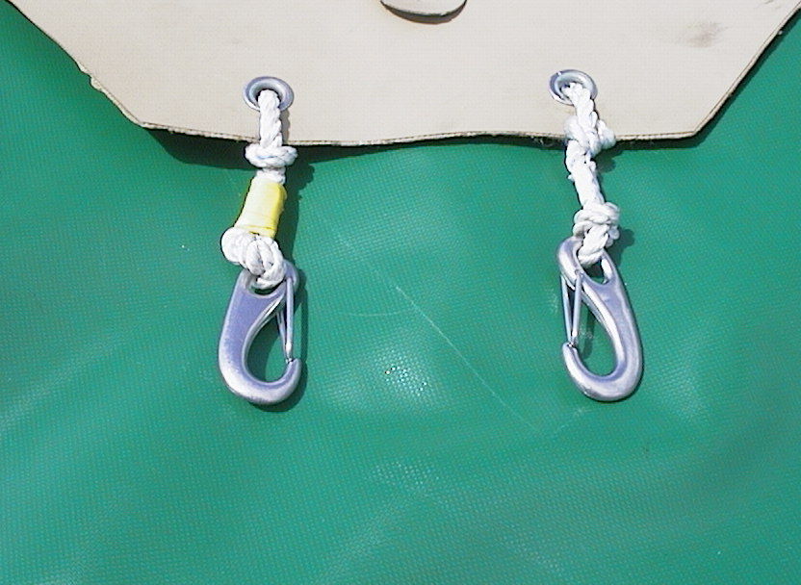 | 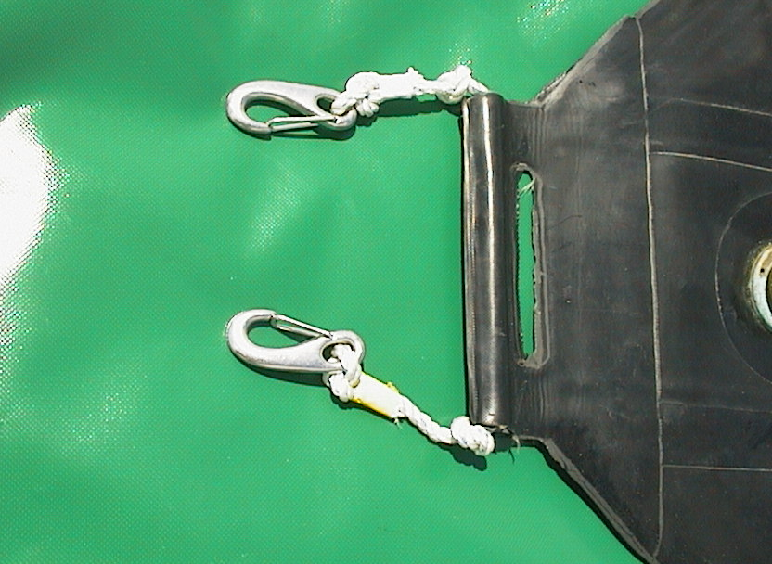
12. EQUIPMENT SAFETY

Referees and/or equipment scrutineers should check the safety of all hulls, motors and other equipment to be used in IRB competition prior to the commencement of competition. In addition, at any stage of competition the Referee is empowered to request repair and/or substitution of any IRB equipment deemed to be unsafe or dangerous.

Final Version
April 2011
Update 2015

