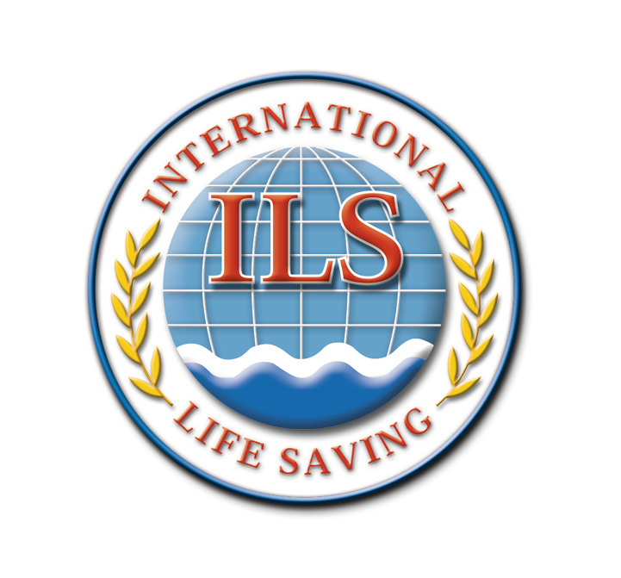

INTERNATIONAL LIFE SAVING FEDERATION

Gemeenteplein 26 - 3010 Leuven - Belgium
Tel: +32 16 896060 - E-mail: ils.hq@telenet.be - Web: http://www.ilsf.org

M E M B E R S H I P A P P L I C A T I O N

As a condition of membership, you agree to maintain affiliation or membership of your national lifesaving organisation.
Please complete legible, in CAPITAL LETTERS

My National Organisation is:

Information
FAMILY NAME
FIRST NAME
DATE OF BIRTH
MAILING ADDRESS
- Street and Number
- Zip and City
- State or Province
- Country
Telephone
E-mail

Application Please tick
I apply for 2 years membership (bronze): 100 Euro
I apply for 5 years membership (silver): 500 Euro
I apply for 10 years membership (gold): 1,000 Euro
I apply for 25 years membership (platinum): 5,000 Euro

Method of payment Please tick
Money transfer | VISA | MasterCard

Card Number: |  | Expiry Date:

ILS Bank details | Bank: BNP Paribas Fortis, 3010 Leuven, Belgium  IBAN (International bank account number) BE91 0012 4219 9376  BIC (Bank international code) GEBABEBB

I have read and understand the terms of ILS membership and I agree that ILS will use my data to add it to its confidential kept database.

Name and date,

------------------------------------

