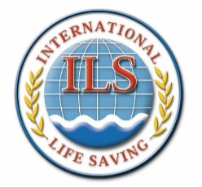
World Water Safety

INTERNATIONAL LIFE SAVING FEDERATION

Gemeenteplein 26 – 3010 Leuven – Belgium
Tel: (32.16) 89.60.60 – E-mail: ils.hq@telenet.be - Web: www.ilsf.org

ILS POLICY – POL 14

Project Approval Policy

Procedures

- Commission, Committee and Working Group projects requests that involve ILS funding should be circulated for input and awareness to the ILS Financial Committee.

- If the ILS Finance Committee recommends support for the project, the ILS Finance Committee will provide budget adjustments and implications for the Board of Directors discussion and decision.

- Upon ILS Board approval of a project, the ILS Finance Committee will instruct the Executive Director to create the ILS Budget adjustments and accounting to the approved project

Policy approved by the Board of Directors on 06/10/2010 and on 03/09/2016.

