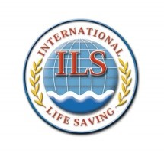
To all ILS Member Federations
25 July 2020

Dear Colleague

Two months ago, we provided some information from the Japan Lifesaving Association (JLA) regarding
the 10th World Masters Games (WMG) and asked you to share it widely through your own websites and social media channels with your Masters competitors to encourage them to participate in this great event.

This is the latest update that the JLA has now been able to provide. It includes a call for any Lifesaving Technical Officials (TOs) who wish to attend the event and take part as one of a group of about 20 overseas TOs that are needed to help run the Masters Lifesaving events of WMG 2021 Kansai. We ask again that you share this through your own channels with your Masters and Technical Officials to encourage them to attend

- WMG 2021 Kansai is on

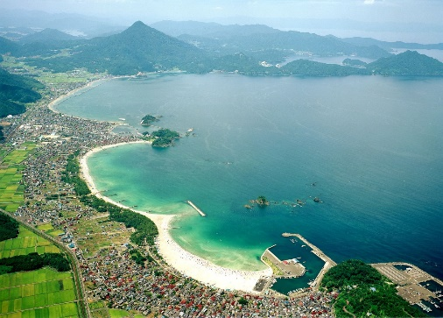
As confirmed in May the whole games run from 17th to 30th May 2021. The Lifesaving events will take place over the two days of 22nd and 23rd May 2021 at the beautiful Wakasa Wada Beach, Takahama Town in the Fukui Prefecture, the first beach in Asia to receive the prestigious Blue Flag certification.

The JLA recognises that there are still some uncertainties because of the different outbreaks of the Covid-19 virus in many countries across the world, but the WMG Organising Committee has confirmed that the events will take place in Japan at the programmed time in 2021.

- Entry deadline and competition features

Entry is already open and closes on Sunday 28 February 2021. For further information and details of how to enter, access this document from the ILS Website: Lifesaving Sport at WMG 2021

There are some notable features in the format of this competition. For the Lifesaving events, a special 25-29 Age Group has been added to the existing 10 normal age categories. And for those competitors who want to participate in the team events, you can join other colleagues make up a team in any of the 7 Team Age Groups.

You do not have to belong to the same club or be from the same nation even to enter the team events. We know Master competitors like to participate in as many events as they possibly can – the WMG 2021 offers the chance to all lifesaving competitors to do just that. The following link is for a promotional video about the World Masters Games: https://www.facebook.com/jla.lifesavingsport/videos/2662459294010402

- Call for International Officials

The JLA is calling for a group of around 20 Lifesaving Technical Officials from around the world to help them run the WMG 2021 Masters Lifesaving events. This document gives details of the positions that need to be filled, and the terms and conditions for applying and attending: Call for International Technical Officials

If you are interested, please contact the JLA on lifesaving.wmg2021@gmail.com They will then send you an application form to apply. If there are more than 20 people who apply, they will allocate the positions on a “first come, first served” basis, so please contact them as soon as possible.

