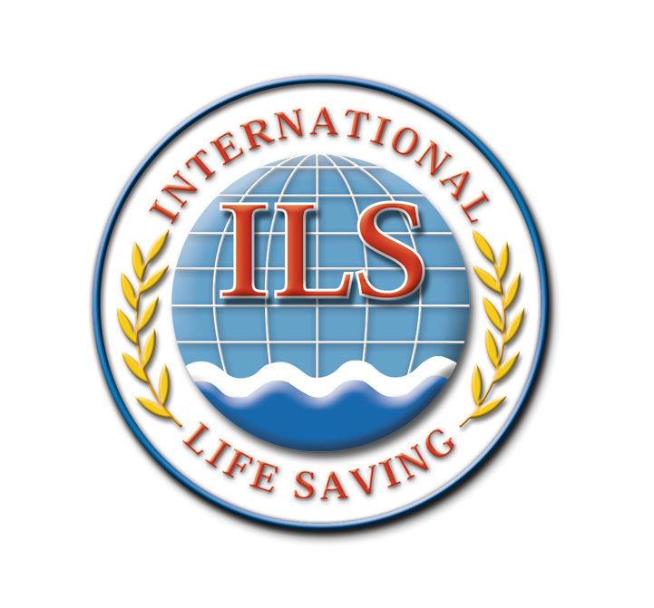

INTERNATIONAL LIFE SAVING FEDERATION

Gemeenteplein 26 - 3010 Leuven - Belgium
Tel: +32/ (0)16 896060 – hq@ilsf.org - www.ilsf.org

COMPETITION SANCTIONING POLICY AND GUIDELINES

- Preamble
All competitions organised under the patronage of ILS should be sanctioned. All sanctioned competitions shall comply with the ILS Rule Book Section 2.1 and Technical Bulletins posted on the ILS website: https://www.ilsf.org/lifesaving-sport/rules/.

World Records can only be broken in competitions that are sanctioned and in compliance with the ILS Rule Book, Section 2.5, World Records and Section 8, Facility and Equipment Standards and Scrutineering Procedures. The ILS Record Application Form is included at the end of Section 2 of the Rule Book or available on the ILS website to download.

- Definitions
Lifesaving Sport - An activity involving physical effort and skill in which an individual, or team competes against others. The activity can be recreational or competitive, is capable of achieving a result, and is governed by a set of rules issued by the International Life Saving Federation.
Discipline - A discipline is a subset of a sport, comprising one or more events of a similar nature. Lifesaving Sport is composed of different disciplines such as: Pool, Ocean & Beach, Simulated Emergency Response Competition (SERC), Surf Boats, Inflatable Rescue Boats, and others.
Competition - A competition is composed of one or more disciplines.
Championship - A championship is a type of competition. For example, the National Teams Lifesaving World Championships.
Event - An event is a series of races with the same prescribed set of rules and conditions. For example: sprinting and running events, beach flag events, etc.
Race - A race is a single contest of speed or distance within an event in which the winner is determined by time or distance. For example, a single heat is a race, the A-final is a race.

- Introduction
The International Life Saving Federation (ILS) is committed to a high standard of competition presentation through a process of Competition Sanctioning. To assist prospective Host Organisations please refer to:
- The ILS Competition Rule Book - can be viewed and downloaded from the website: https://www.ilsf.org/lifesaving-sport/rules/.
- The current Handbook of the Life Saving World Championships - can be viewed and downloaded from the website: https://www.ilsf.org/lifesaving-sport/rules/.

Note: The ILS Rule Book contains the rules for events and world record requirements etc whereas the ILS LWC Handbook contains details such as ILS age categories, membership requirements and eligibility criteria to participate in National and InterClub teams. Both documents are relevant to the conduct of ILS Sanctioned Competition, Where there is a material difference the Rulebook is to be the point of reference.

- Sanction Procedure Step by Step
4.1. The Host Organisation wishing to conduct the competition shall forward the following documents to the National Federation (Submit the Sanctioning Application Form at least 28 days’ in advance of competition date to allow for the processing and approval of the application details):
- Sanctioning Application Form.
- Facility and Equipment Inspection Report
- Certificate of Insurance
- Safety and Emergency Plan.
A payment of 100 Euro is also due and payable to ILS at the time of application for a Sanction.
4.2. The National Federation is responsible to verify the Sanctioning Form, insurances and all related documents.
4.3. When the National Federation endorses the competition it sends the Sanctioning Form with payment to the ILS Headquarters and a copy of the endorsement to the Host Organisation.
4.4. A sanctioning site visit can be organised (if required) by an appointed ILS Sport Commission’s representative.
4.5. The Headquarters include the event in the official ILS Calendar under sanctioned competitions. This serves as an official notification.
4.6. Post-Event – Record Application Form if applicable.

Notes:
- A Sanctioning Form must be submitted for each competition on an individual basis.
- Series Competitions that are identical in venue, course design and distance can be treated as one application in terms of the Sanction Forms. Fees are applicable and payable for each competition in the Series.
- ILS World Records can only be achieved at ILS Sanctioned Competitions.
- Competitions sanctioned by ILS may be published on the official ILS Calendar: https://sport.ilsf.org/calendar.

- Technical Support
Technical support to conduct the event in accordance with the “ILS Competition Rule Book” may be required by ILS. The number of Technical Officials will be dependent upon the competition status and the number of competitors and will be determined in consultation with the ILS Sport Commissioner.

- Sanctioning and Other Fees (2016-2017)
The sanctioning fee per event is 100 Euro (payable when application is made).

NOTE: If it is deemed appropriate and ILS officials are to be used to assess the application in a technical capacity. This will attract a fee for service. These will be negotiated on a competition by competition basis.

- Entry Forms, Official correspondence and other Promotional material
Entry forms must carry the following expression: “Sanctioned by the International Life Saving Federation” and must carry the ILS logo.

- Change to Competition
Should the grounds upon which sanctioning was granted changes at any time prior to the competition, notification must be given to ILS, whereby the sanctioning will be immediately reviewed. Should the review result in the competition not meeting sanctioning standards, ILS reserves the right to advertise withdrawal of sanctioning.

- Competition Rules
All competitions must be conducted in accordance with “ILS Competition Rule Book”. The event rules, pool specifications, and equipment that pertains to the pool events where world records can be established cannot vary from the “ILS Competition Rule Book if such records are to be accepted *.

Note 1: if a competition pool does not comply for all events (e.g. a depth or a ledge at a particular point, etc.), or non ILS approved equipment (e.g. a non-approved manikin), a part sanction may be granted specifying any exceptions that apply to the setting of world records.
Note 2: As part of the competition entry process, the host must also advise participants of any events that do not meet the criteria for ILS world records to be recognised.

If the conduct of the competition or events is to otherwise vary from the ILS Competition Rule Book (e.g. competitor eligibility to participate, age categories, the type or events or rules of the events being conducted, etc.) the host is to include details of the proposed variations in the sanctioning application.

Note 1: Dependent on the extent of the variation, the ILS sanction provided may not include the approval to establish world records in pool events (irrespective of pool compliance).
Note 2: As part of the competition entry process, the host must also advise participants of any events that do not meet the criteria for ILS world records to be recognised.

- Permits and Approvals
Host Organisations are responsible for obtaining all required permits and approvals such as; the Local Government (Council), the Police and emergency services, etc., the approval for use of private property and other facility user group considerations.

- Insurance / Safety and Emergency Plan
- All competitions must have public liability insurance of at least 10,000,000 Euro.
- A copy of the insurance “Certificate of Currency” must be forwarded to ILS prior to the commencement of competition.
- A Safety and Emergency Plan for the competition must be submitted to ILS as an attachment to the application.

- Equipment
All equipment to be used for a competition must comply with ILS specifications if ILS World records are to be recognised.

- Facilities Standard
All facilities used for competition (pool, beach, ocean, lake, etc.) must meet and comply with ILS specifications.

Note: Also refer to clause 9 for partial approval of pools.

- Anti-Doping
All sanctioned events must comply in process and adhere to the ILS anti-doping policy. This policy can be found on the ILS website: https://www.ilsf.org/lifesaving-sport/rules/anti-doping/ .

As per the ILS Education Plan (refer: https://www.ilsf.org/lifesaving-sport/rules/anti-doping/) an undertaking is sought for:

- Anti-Doping/Clean Sport Communication: The Host Organisation to publish Anti-Doping messaging as part of the sanctioned competition’s promotion, entry, messaging and other documentation as well as specific announcements at the competition
- National Teams: The Host Organisation to require athletes, coaches, managers and medical personnel to have completed current World Anti-Doping Agency (WADA) approved National Anti-Doping Organisation (NADO) or WADA Anti-Doping Education Learning (ADEL) to be undertaken prior to the Sanctioned competition.
Note: It will be the responsibility of the host to ensure and seek evidence of compliance.
- Interclub Teams: The Host Organisation to recommend that athletes, coaches, managers and medical personnel undertake NADO or WADA ADEL prior to the Sanctioned competition.
Note: Upon request ILS will assist Host Organisations with assist advice, and with draft wording for circulars, messages and announcements, etc.

- Duty of Disclosure
Before the Host Organisation enters into a sanction with ILS all matters requested pertaining to the competition will be disclosed to ILS through this sanctioning process. If a Host Organisation fails to comply with your duty of disclosure, ILS may withdraw its sanction without prior notice.

- Sanctioning Fees
You are responsible for transferring the sanctioning fee of 100 Euro to ILS. The fee should be transferred to the ILS account:
Bank name: BNP Paribas Fortis
Bank address: Victor Decosterstraat 42, 3000 Leuven, Belgium
IBAN number: BE91 0012 4219 9376
Bank swift code: GEBABEBB

If fees are not paid before the start of the event, the sanctioning is void.

- Prize Money
ILS favours a policy of equal division of prize money (if any) for male and female competitors.

- Date
If the date of mailing does not appear on the Sanctioning Form the National Federation as well as ILS will use the e-mail date as the application date.

- Sanctioning Agreement
By signing the Sanctioning Form and its declaration, the Host Organisation declares that they have read and understood the ILS sanctioning guidelines and recognises that it is their responsibility to conduct a fair and safe competition. The Host Organisation further understands that the guidelines are minimal and special conditions and may require further cautions and actions. The Host Organisation also agrees also that ILS has the authority to request the cancellation of the competition or withdrawal of the ILS sanctioning if minimum safety requirements are not in place. The Host Organisation also agrees that ILS may announce publicly, before the commencement of the competition, the withdrawal of ILS sanctioning and insurance cover if applicable.

The Host Organisation understands that the information supplied on the Sanctioning Form will be relied upon by ILS in sanctioning this event, and any changes made must be notified in writing to ILS as soon as practicable. It is further agreed that the ILS will be included in any waiver or release from liability.

In consideration of ILS considering any event sanction application, the Host Organisation and ILS (through its National Federation) agree as follows:
1. Sanction is neither automatic nor irrevocable. ILS at its absolute discretion may conditional or unconditionally sanction, refuse to sanction, or withdraw its sanction of the competition. For example, ILS might withhold or withdraw a sanction if it considers the competition to be a risk competitor or public safety, to be unprofessionally organised, to be financially under-resourced, to breach ILS’s rules or policies, or to be detrimental to the promotional or regulatory interests of ILS, or that the competition facilities and/or equipment does not meet ILS standards. The Host Organisation has no claim against ILS in respect of any determination made by it.
2. ILS reserves the right to change or amend its sanctioning policies, procedures and requirements from time to time.
3. If sanctioned, the Host Organisation must comply with all rules and directions made by ILS in respect of the conduct of this competition and all conditions of any sanction conferred by ILS. Failure to comply with any of these rules, directions or conditions entitles ILS to (amongst other things) withdraw any sanction at any time.
4. If ILS declines to sanction the competition or, having sanctioned the competition, elects to withdraw its sanction for any reason, the Host Organisation irrevocably authorises ILS to publish the fact, nature and reasons for its decision to decline or withdraw sanction to any entity or person ILS thinks fit, including (but not limited to) prospective competitors, sponsors and the general public.
5. It is the Host Organisation’s responsibility to conduct a safe and fair competition. Any standards and conditions imposed by ILS for this event and events generally are minimal standards only. The Host Organisation acknowledges that:
a) A competition is not necessarily safe or viable because it has been sanctioned by ILS.
b) Special or unusual conditions may require further precautions and actions in the interests of competitor, participant, or spectator safety.
c) Public liability insurance cover and/or any other required insurance arranged by ILS or required by ILS as a condition of sanction, although negotiated and arranged in good faith by ILS, might not cover all risks to the Host Organisation, competitors, participants and spectators associated with the competition. ILS does not warrant that the terms and coverage of any such insurance are adequate for the purposes of the Host Organisation, competitors, participants or spectators. The Host Organisation must satisfy itself that it is adequately insured.
6. The Host Organisation must not advertise the competition as sanctioned unless and until ILS has sanctioned it and all conditions of sanction have been complied with. If ILS withdraws any sanction, the Host Organisation must:
a) Prior to the competition, advise all competitors and prospective competitors of withdrawal of the sanction.
b) Remove any references to ILS’s sanction from advertising or promotional material for the competition.

The ILS Sanctioning Policy and Guidelines was adopted by the ILS Board of Directors on 16 February 2006 and has been reviewed and updated in February 2008, May 2010 June 2016, and June 2026. It will continue to be reviewed every two years by the ILS Sport Commission, or as required.

